|  |
| --- |
| **URS** |
|  |
| **User requirement specification (URS) for Prefilled Syringe module in the Sample Opening Station workcell** |

|  |  |  |  |
| --- | --- | --- | --- |
| **DOCUMENT APPROVAL** | | | |
| **Prepared by:** | **Name** | **Full signature** | **Date** |
| Senior Research Scientist | Christoffer Bo Matthiesen / CFBM |  |  |
| **Approver** | **Name** | **Signature** | **Date** |
| Project Manager | Anne Munch / QAMN |  |  |
| Senior Skilled Worker | Mads Skov Hansen / ZMHE |  |  |
| Associate Manager | Hanne Winning / HWII |  |  |
| Director | Fredrik Kryh Öberg / FRQB |  |  |
|  |  |  |  |

Contents

1 Introduction 3

2 Purpose 3

3 Scope 3

4 Process Description 3

4.1 Sample flow diagram 3

4.1.1 Sample Opening Station flow diagram 4

4.2 Prefilled Syringe module 5

4.2.1 Prefilled Syringe module flow diagram 6

5 Requirements 7

5.1 Equipment requirements 7

5.1.1 Plunger Remover sub module 7

5.1.2 Liquid Handler sub module 7

5.1.3 Needle Cap remover sub module 7

5.1.4 Piston presser sub module 7

5.1.5 Deepwell plate sub module 7

5.2 Labware requirements 7

5.3 Cleaning requirements 7

5.4 Failure Handling requirements 8

5.5 General requirements 8

5.6 IT related requirements 8

5.6.1 Hardware Requirements 8

5.6.2 Software Requirements 9

5.6.3 Network Requirements 9

5.6.4 Availability Requirements 9

5.6.5 Access Control and User Management requirements 9

5.6.6 Disaster Recovery requirements 10

5.6.7 Security requirements 10

5.7 Documentation requirements 10

5.8 HSE requirements 10

5.8.1 Standards 10

5.8.2 Chemical- and noise related requirements 11

5.9 Service requirements 11

# Introduction

The aim of the Sample Opening Station project (SOS) is to implement a fully automated workflow for opening and emptying the four most used primary pack sample containers in DP development area. The four chosen container types are the 1.5 Penfill, 3.0 ml Penfill, 1.0 ml syringes (PFS) and H2HN Vials. The automated workflow is broken down into different modules based on the unit operation. Since the primary pack sample containers are design for Novo Nordisk products, no Commercial of the shelf (COTS) is available therefor Novo Nordisk will develop three unique solutions for opening Penfills, PFS and H2HN vials. It is planned that these solutions will be built by workers in the DSI area more precisely department 6503 – Automation.

# Purpose

The purpose of this URS is to function as an agreement between the SOS project and department 6503 and to describe the requirements to the Prefilled Syringe module.

# Scope

The scope of this URS is to define the requirements to the Prefilled Syringe module to enable automated sample preparation of samples stored in PFS container. The URS will focus on what is needed to ensure that the system is fit for intended use while ensuring robustness, quality, flexibility of use, and integration with Novo Nordisk IT infrastructure.

See table below for the structure and nomenclature of the requirements in this document.  

| Req. no. | Requirements | Type |
| --- | --- | --- |
| X | The equipment must be able to | CR |
| y | The equipment has the option to | NR |

Type is either CR (Compulsory Requirement) or NR (Necessary Requirement). Necessary requirements are requirements which must be fulfilled/adhered to, but there might be other/better solution which will still satisfy the intention of these requirements.

# Process Description

## Sample flow diagram

The Prefilled Syringe module will be an essential pierce in the SOS project and will contribute to the overall sample opening process which is described in 4.1.1. The expected flow for the Prefilled Syringe module is described in 4.1.2. Since the module will be used in the laboratory for everyday use it is paramount that the module is robust.

### Sample Opening Station flow diagram

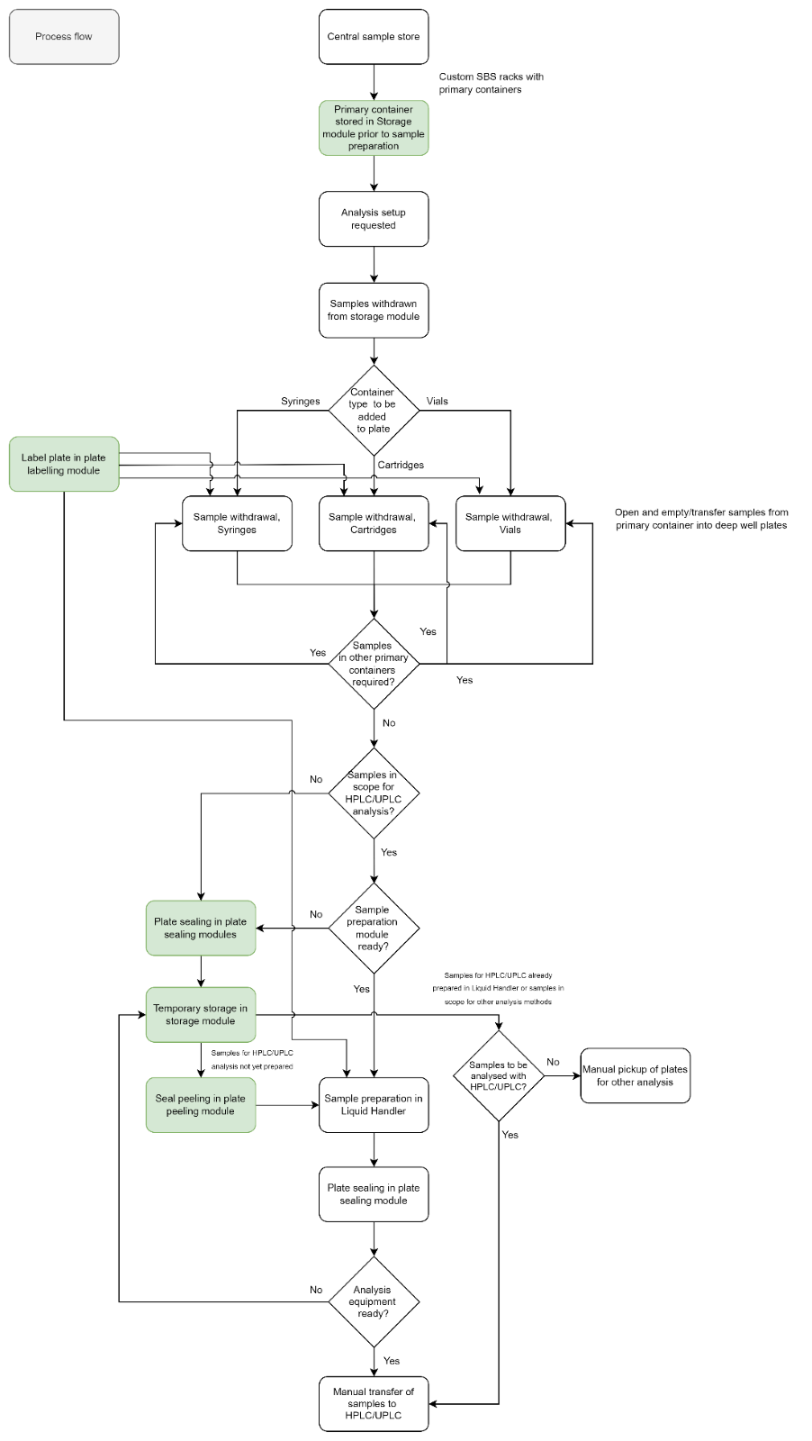

## Prefilled Syringe module

Since the purpose of the prefilled syringes module is to be operated as a part of a fully automated solution the focus doing development of the module must be robustness and proper error handling. Further since the Sample Opening Station is a part of the MDL project plan timely deliverable of the module is key. The implemented solution will be used both during regular working hours bot also during the night, sample handling time is therefore not critical, however handling of a full QC-batch (48 samples) should not exceed one hour

During operation in the MDL format the SOS and therefore the prefilled syringes module will be controlled be digital input from the selected schedular. The module must be able to extract the content of a prefilled syringe in two different ways, either through the needle (Front end) or by removing the plunger and aspirate the sample (Back end). The prefilled syringes module is expected to handle the following physical input and output and support the stated functions.

**Input:** Empty deepwell plate, Prefilled syringe Racks

**Output:** Deepwell plate containing samples.

**Functions:**

* It should be possible, based on digital input, to choose the sample location in the deepwell
* Handling of waste such as tips, needle caps, plungers, and emptied syringes.
* Handling of reusable utilities such as empty syringe racks.
* Security against sample contamination and cross contamination
* Visual confirmation of critical steps eg. Sample barcode confirmation, Plunger removed, needle cap removed.

### Prefilled Syringe module flow diagram

Racks containing up to xx prefilled syringes will be delivered by and external module so the prefilled syringe module should have a designated input area for these racks.

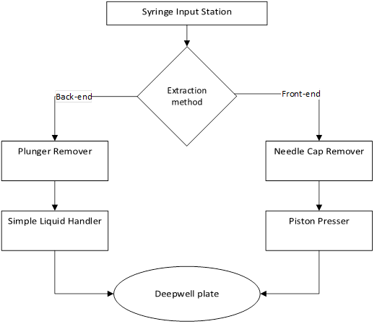

# Requirements

## Equipment requirements

### Plunger Remover sub module

| **Req.No.** | **Requirement** | **Type** |
| --- | --- | --- |
|  | The system must be able to safely remove the rubber plunger | CR |
|  | The system must be able to visually check if the plunger is removed before aspirate the sample | NR |

### Liquid Handler sub module

| **Req.No.** | **Requirement** | **Type** |
| --- | --- | --- |
|  | The system must have single-channel pipetting tool, with single use tips. | CR |
|  | The single-channel pipetting tool must be able to aspirate and dispense samples in the volume range of 300 - 1000µl | CR |

### Needle Cap remover sub module

| **Req.No.** | **Requirement** | **Type** |
| --- | --- | --- |
|  | The system must be able to safely remove the needle cap | CR |
|  | The system must be able to visually check if the needle cap is removed before pressing the sample out | CR |

### Piston presser sub module

| **Req.No.** | **Requirement** | **Type** |
| --- | --- | --- |
|  | The system must be able to press a defined volume of sample to the deepwell | CR |

### Deepwell plate sub module

| **Req.No.** | **Requirement** | **Type** |
| --- | --- | --- |
|  | It must be possible to assign a sample to a specific well position | CR |
|  | The system must ensure no sample contamination nor cross contamination | CR |

## Labware requirements

| **Req.No.** | **Requirement** | **Type** |
| --- | --- | --- |
|  | The system must be able to handle deepwell plates with the following dimensions LxWxH: 127.76 mm x 85.48 mm x 42.50 mm, see appendix 1 for technical drawings | CR |
|  | The system must be able to handle prefilled syringe racks with the following dimension LxWxH: 127.76 mm x 85.48 mm x 17.50 mm, see appendix 2 for technical drawings | CR |
|  | The system must be able handle individual prefilled syringes with the following dimensions LxD: ~81 mm x 8.15 mm, see appendix 3-6 for technical drawings | CR |

## Cleaning requirements

| **Req.No.** | **Requirement** | **Type** |
| --- | --- | --- |
|  | The system must be designed to reduce spillage on the module deck. | NR |
|  | The system must be design so it is easy cleanable | NR |

## Failure Handling requirements

| **Req.No.** | **Requirement** | **Type** |
| --- | --- | --- |
|  | The system must have a build in feature to ensure that the needle cap is removed. . | CR |
|  | The instrument shall have an emergency stop function if a human body part enters the deck while in operation. | CR |
|  | The instrument must ensure recovery from a minor failure like a plate drop or collision and continue the method following user intervention to clear error. | CR |
|  | The instrument must be able to recover from a major failure like an emergency stop intervention which may occur from pressing an emergency stop button and continue a method. | NR |
|  | In case the software controlling the equipment shuts down unintentionally, the equipment shall be able to restore data, when the software has been restarted without any data loss. | CR |
|  | In case of a physical crash, the system should be able to notify a user, who can correct the problem, and afterwards the system should be able to continue to finalize its run. | NR |

## General requirements

| **Req.No.** | **Requirement** | **Type** |
| --- | --- | --- |
|  | The instruments must be able to operate with a nominal voltage supply of 100-240V, 50/60Hz or 300VA. | CR |
|  | The system including all its parts/components must be able to work in a temperature range 10 °C to 30 °C. | CR |
|  | The system including all its parts/components must be able to work in a humidity up to 85 % relative (non-condensing). | CR |
|  | The system must be able to handling of waste such as tips, needle caps, plungers, and emptied syringes. | NR |

## IT related requirements

The following section contains general requirements towards IT-platform and infrastructure for the equipment and solutions.

### Hardware Requirements

| **Req.No.** | **Requirement** | **Type** |
| --- | --- | --- |
| 1. | The system should be delivered using hardware components that ensures high uptime and possible future expansion. If a control PC is used the following must be fulfilled as a minimum:   * CPU load during normal operation must not exceed 50%. * No more than 70% spare memory must be used during normal operation * Network cards should be 1GB/s * Hard disks should be of SSD type and configured in RAID 1. At least 100% spare capacity must be available. * Battery backup should be provided for 10 minutes operation, and a controlled shutdown in case of power outage should be configured.   The launch date of used components should not exceed 3 years | NR |
| 2. | The system must be installed with an Uninterruptible Power Supply (UPS) system to allow for PC/servers/controllers to shut down in a controlled way, to avoid losing data in case of a power break/glitch. For this instance, the UPS system will be provided by Novo Nordisk infrastructure already in place at location of installation. | CR |

### Software Requirements

| **Req.No.** | **Requirement** | **Type** |
| --- | --- | --- |
|  | The system should be delivered using operating systems that are supported at least 2 years from planned go live, by the Vendor of the operating system. | CR |
|  | All applications on the system used for controlling must have an identifiable version and have release notes. | CR |
|  | The system software must have the capacity to be integrated with central software e.g., globalLIMS either directly or via the NN schedular. | CR |

### Network Requirements

| **Req.No.** | **Requirement** | **Type** |
| --- | --- | --- |
|  | All hardware components that need connectivity beyond the system must be assigned to the NN GSDN network either by means of certificates or by MAC address registration. | CR |
|  | It must be possible to operate the system software behind a firewall with well-defined needs for access to external (Internet) resources. | CR |

### Availability Requirements

| **Req.No.** | **Requirement** | **Type** |
| --- | --- | --- |
|  | Application(s) must be designed to run continuously (7d/24h) excluding planned maintenance windows. | CR |
|  | Application(s) running as services must automatically startup when the workstation/server is started/booted. | CR |
|  | Thin/Zero clients used for controlling the system must automatically boot after power failure. | CR |
|  | Thin/Zero clients used for controlling the system must automatically connect to the configured workstation/server at startup. | CR |
|  | It must be possible to fully recover and resume execution in case of a hardware failure, software failure, network failure, power outage or other fault.  Desired RTO (Recovery Time Objective) is (7) days  Desired RPO (Recovery Point Objective) is (24) hours. | CR |

### Access Control and User Management requirements

| **Req.No.** | **Requirement** | **Type** |
| --- | --- | --- |
|  | Applications and the IT infrastructure must be protected from unauthorized access by a combination of physical and logical access control features. | CR |
|  | The applications, platforms and infrastructure services must always be running regardless of whether a user is operating the system or not. | CR |
|  | Default vendor passwords must be changed, or default accounts must be disabled following installations of systems or software. | CR |
|  | Passwords for service accounts must be changeable by NN. | CR |

### Disaster Recovery requirements

| **Req.No.** | **Requirement** | **Type** |
| --- | --- | --- |
|  | It must be possible to re-establish the system following a documented procedure. | CR |
|  | The system must be supplied with a backup solution that can fulfil RTO/RPO objectives described above.  It must be possible to generate accurate and complete backups of data in the system without interrupting the running operations. | CR |
|  | It must be possible to restore data in the system using the backup and restoration procedure. | CR |

### Security requirements

| **Req.No.** | **Requirement** | **Type** |
| --- | --- | --- |
|  | The system must be designed to ensure periodically anti-malware scanned with an up-to-date anti-malware scanner. | CR |
|  | The system must be designed to ensure that time used is consistent and automatically changes between daylight savings time alternative synchronization with the NN network could also be used. | CR |
|  | If available, remote access solutions must include strong authentication and communication must be encrypted. | CR |

## Documentation requirements

|  |  |  |
| --- | --- | --- |
| **Req. No.** | **Requirement** | **Type** |
|  | All equipment and solutions must be delivered with design documentation, test documentation and as-built documentation. | CR |
|  | All equipment and solutions must be delivered with user manuals and maintenance guidance plan. | CR |

## HSE requirements

This section lists the used standards for supporting a sound Health & safe working environment, where possible these standards must be used.

### Standards

| **Req.No.** | **Requirement** | **Type** |
| --- | --- | --- |
|  | ISO 12100:2010 Safety of machinery - General principles for design - Risk assessment and risk reduction. | CR |
|  | EN ISO 11161:2007 Safety of machinery – Integrated manufacturing systems – Basic requirements. | CR |
|  | EN 60204-1:2006 Safety of machinery – Electrical equipment of machines – Part 1: General requirements. | CR |
|  | EN 61010-1:2010/A1:2019: Safety requirements for electrical equipment for measurement, control, and laboratory use – Part 1: General requirements. | CR |
|  | EN ISO 13849-1:2015: Safety of machinery – Safety-related parts of control systems – Part 1: General principles for design. | CR |
|  | EN ISO 13849-2:2015: Safety of machinery – Safety-related parts of control systems – Part 2: Validation (Only if GXP applicable). | CR |
|  | EN 1005-2:2003+A:20008, Safety of machinery – Human physical performance – Manual Handling of machinery and component parts of machinery. | CR |
|  | EN 894-4:2010 Safety of machinery – Ergonomics requirements for the design of displays and control actuators – Part 4: Location and arrangement of displays and control actuators. | CR |
|  | EN ISO 10218-1:2012: Robots and robotic devices – Safety requirements for industrial robots – Part 1: Robots. | CR |
|  | EN ISO 10218-2:2011: Robots and robotic devices – Safety requirements for industrial robots – Part 2: Robot systems and integration. | CR |

### Chemical- and noise related requirements

| **Req.No.** | **Requirement** | **Type** |
| --- | --- | --- |
|  | The complete unit must not produce noise larger than 70 dB(A). | CR |

## Service requirements

| **Req.No.** | **Requirement** | **Type** |
| --- | --- | --- |
|  | The system must be easy serviceable. | NR |
|  | The system must include a service guidance plan. | NR |
|  | System end user must be trained in the required service. | NR |

**Appendix 1 – Technical drawings of Waters deepwell plate**

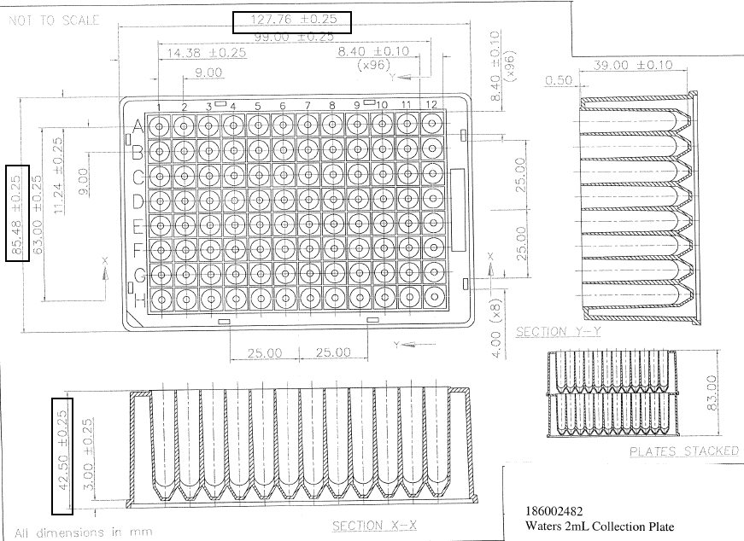

**Appendix 2 – Technical drawings of prefilled syringe rack**

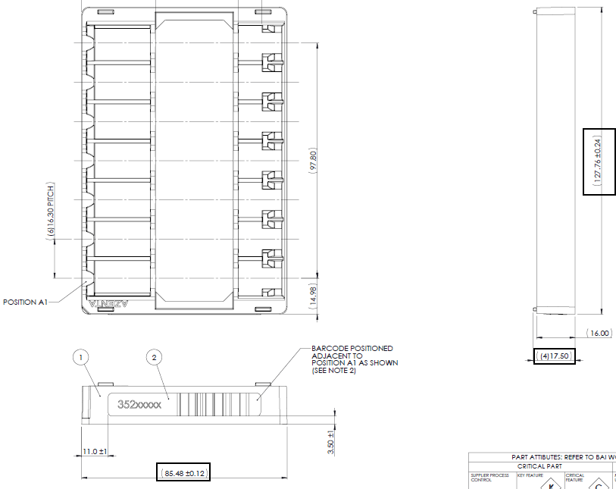

**Appendix 3 – Technical drawings of prefilled syringe “SyriQ Biopure 1 ml (Schott)“**

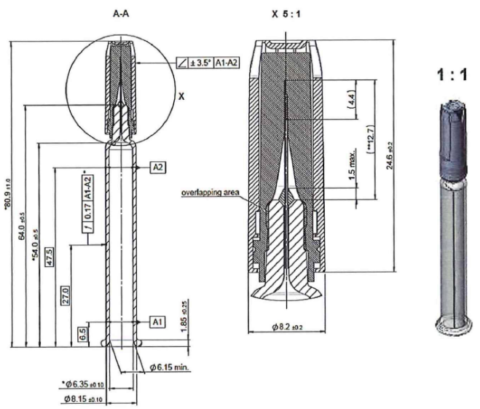

**Appendix 4 – Technical drawings of prefilled syringe “Neopak SPR 1 ml (Vetter/Beckton Dickinson)”**

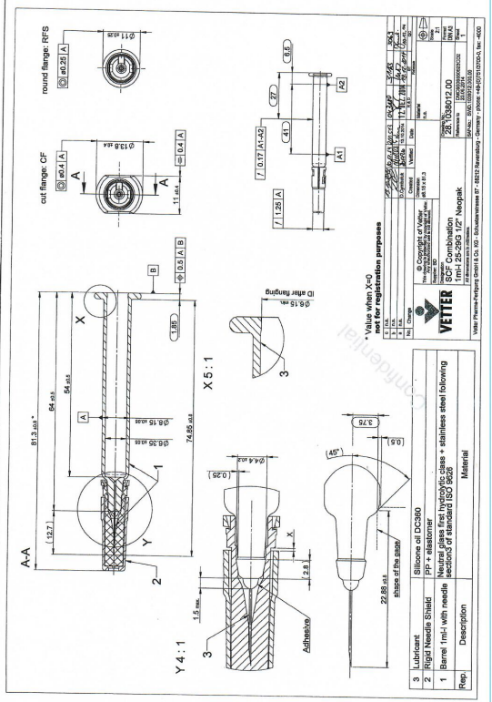

**Appendix 5 – Technical drawings of prefilled syringe “Syringe BRL 1ml (OMPI)”**

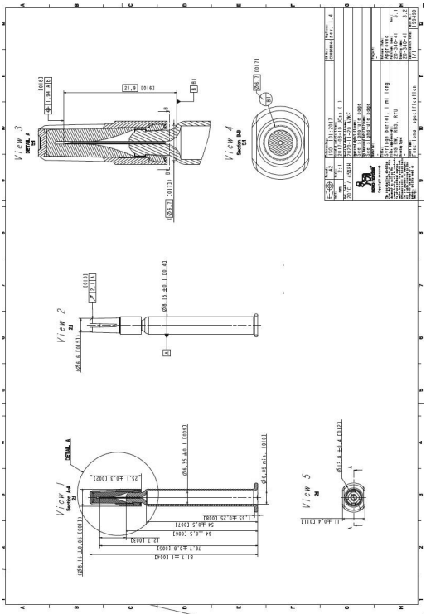

**Appendix 6 – Technical drawings of prefilled syringe “RFT Syringe 1.0 mL long (Gerresheimer)”**

